|  |  |
| --- | --- |
|  |  |
|  |  |
|  |  |

**Fig. S1**. Core genome and pan-genome development plot projections for a) and b) *Archaeoglobus*, c) and d) *Desulfovibrio*, and e) and f) *Desulfotomaculum*. For Core genome development plot extrapolation: the red curve shows the fitted exponential decay function, and the blue and green curves indicate the upper and lower boundary of the 95% confidence interval.

**a)**

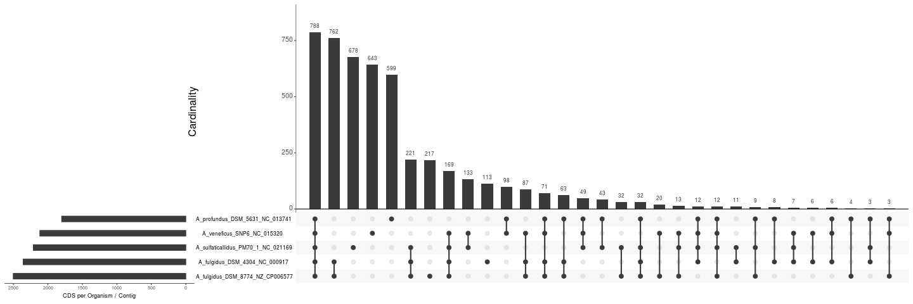

**b)**

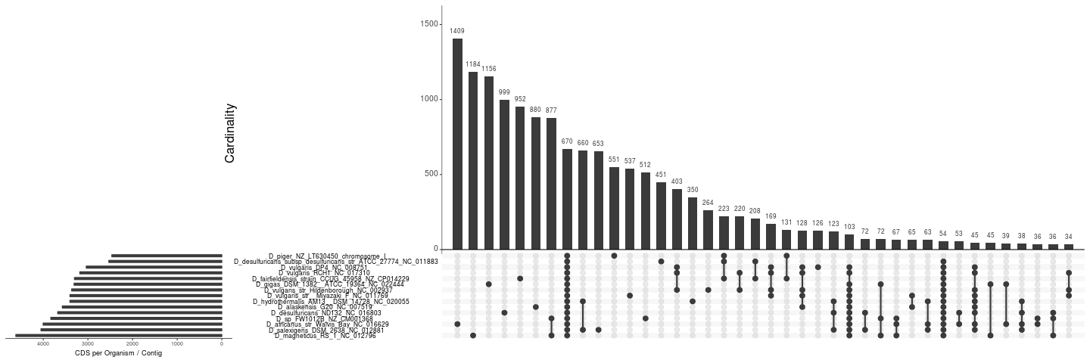

**c)**

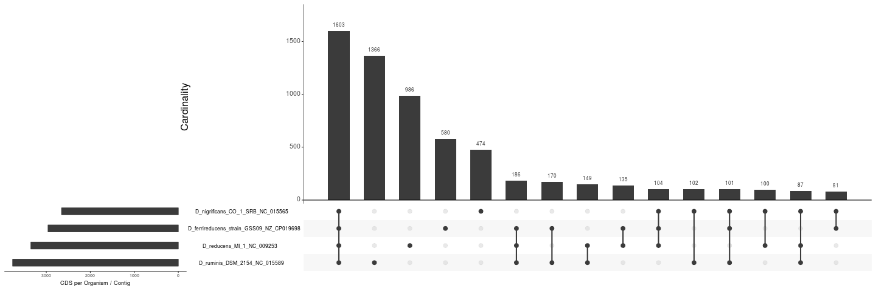

**Fig. S2**. UpSet plot of a) *Archaeoglobus*, b) *Desulfovibrio*, and c) *Desulfotomaculum*.